Diamond Price Analysis Project
Name | Mayur Gadhave
Roll Number | SA213
Project Title | Diamond Price Analysis Using Python
Dataset | Diamonds dataset
GitHub Link | Paste your GitHub repository link here before final submission

Problem Statement
I am analyzing the Diamonds dataset to understand which features are most strongly related to diamond price. This can help a jewelry shop or buyer make better pricing decisions by identifying how size, quality, and dimensions affect the final cost.
Dataset name: Diamonds. Source: Seaborn sample dataset repository. Original size: 53,940 rows and 10 columns. The columns are carat, cut, color, clarity, depth, table, price, x, y, and z.
Column | Meaning
carat | Weight of the diamond
cut | Quality of cut
color | Color grade
clarity | Clarity grade
depth | Total depth percentage
table | Top width relative to widest point
price | Price in US dollars
x, y, z | Dimensions of the diamond in millimeters

Imports - code screenshot
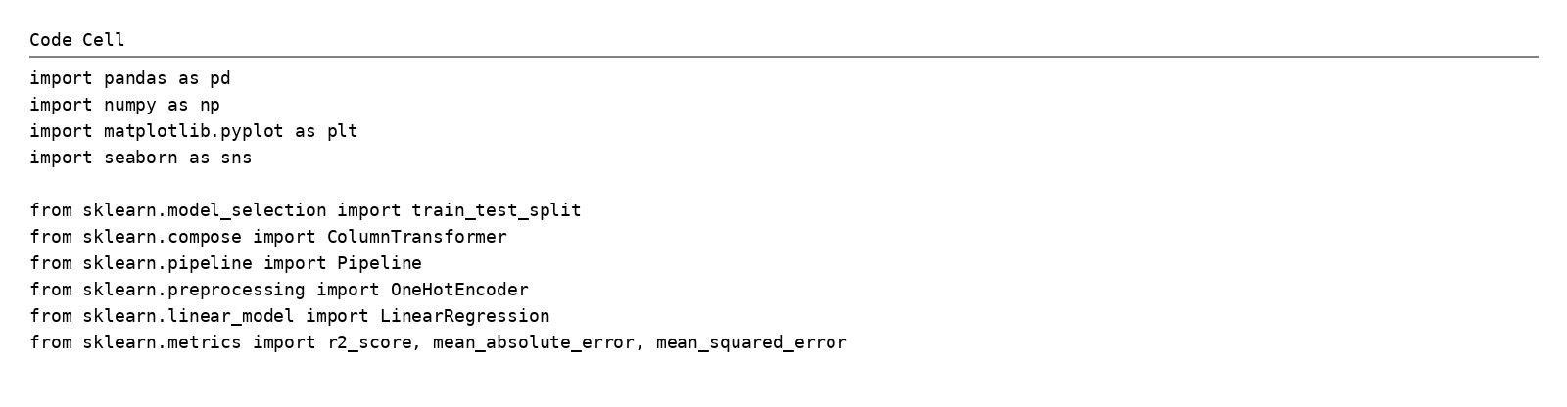
All libraries were imported in one code cell as required.

Data Loading and Basic Information

Code screenshot
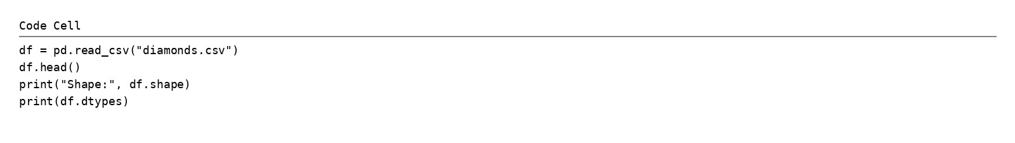

Output screenshot
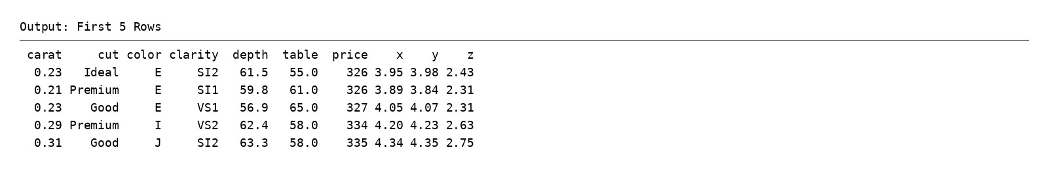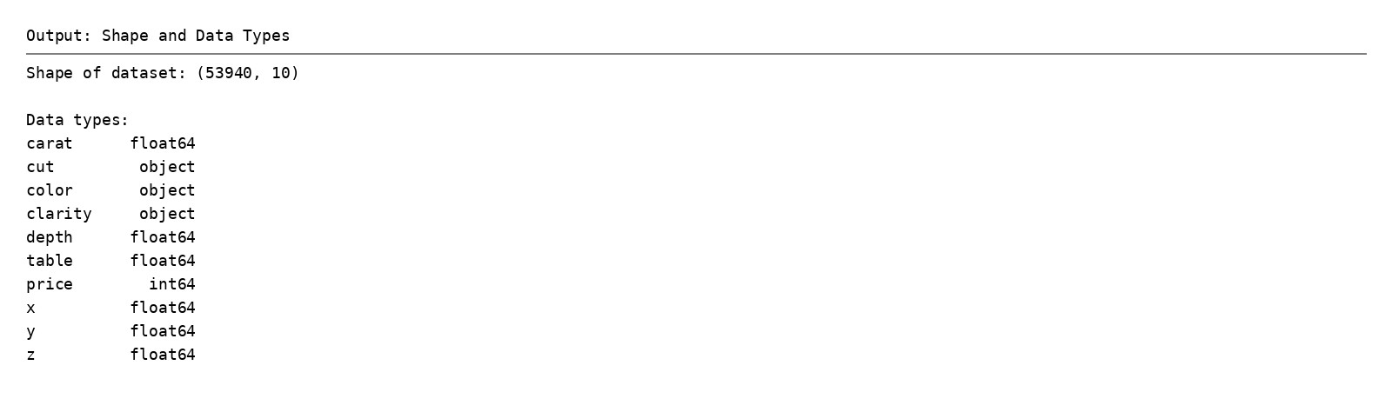
The dataset satisfies the assignment rule because it has more than 1,000 rows, contains 10 columns, and includes both numeric and categorical data.

Data Cleaning

Code screenshot
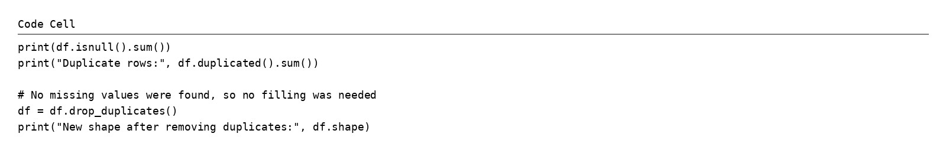

Output screenshot
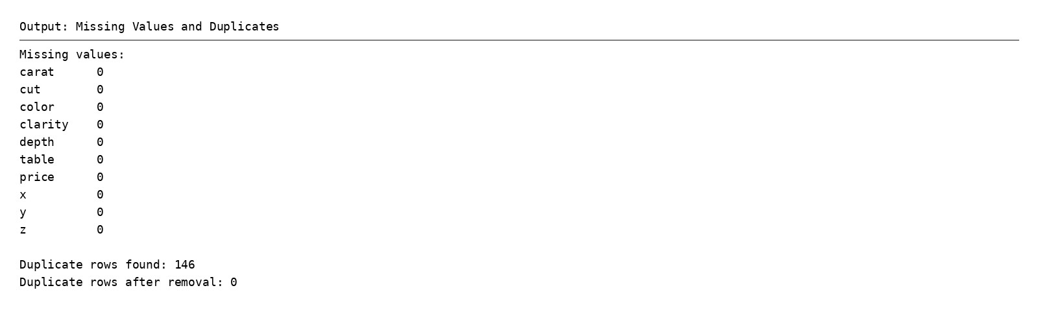
No missing values were found, so no filling was required. Duplicate rows were removed because repeated records can make statistics and model results less reliable.

Descriptive Statistics

Code screenshot
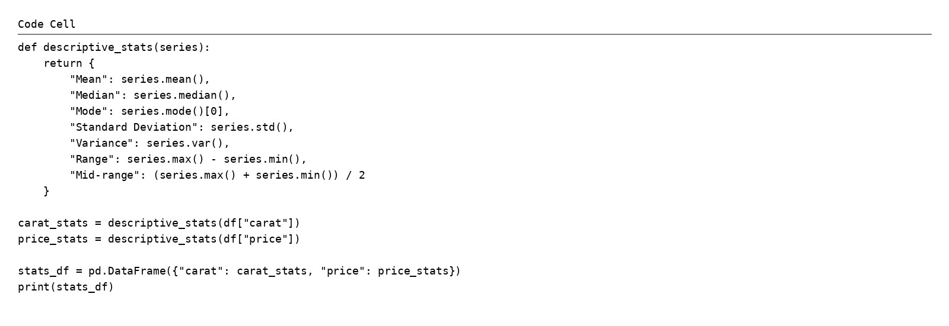

Output screenshot
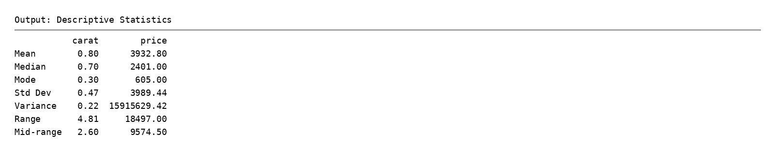
For the numeric columns carat and price, I calculated mean, median, mode, standard deviation, variance, range, and mid-range as required. Price has much larger spread than carat, which shows strong variation in diamond prices.

Visualizations

Histogram
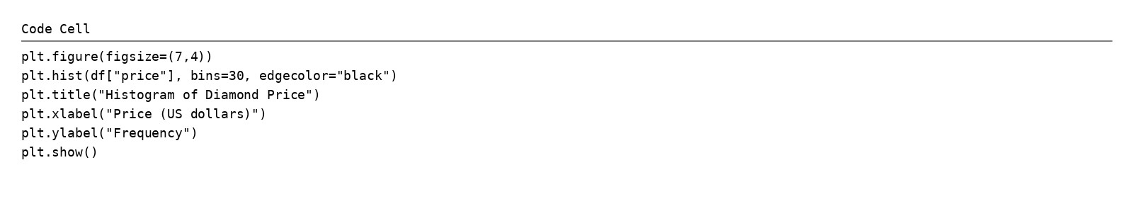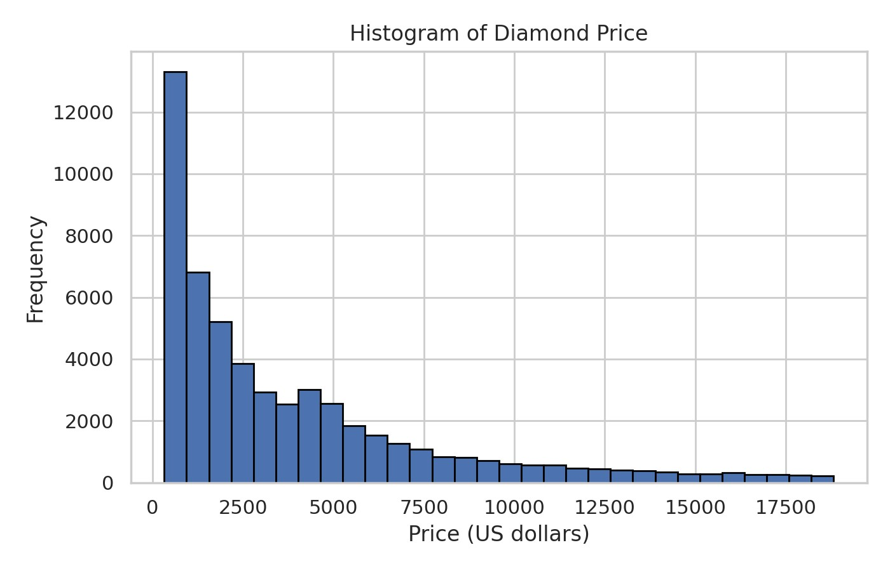
Interpretation: Most diamonds are concentrated in the lower price range, while fewer diamonds appear at very high prices. This shows that the price distribution is right-skewed.

Bar Chart / Countplot
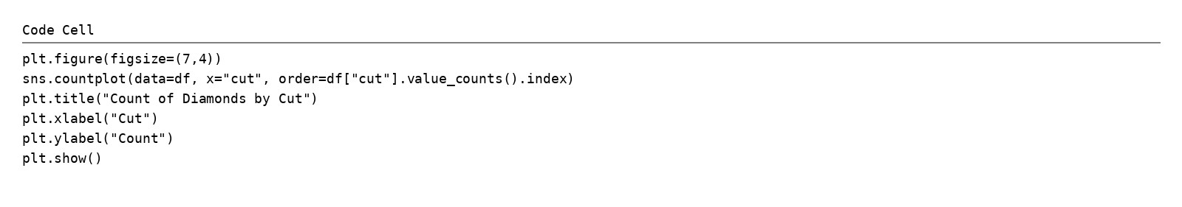
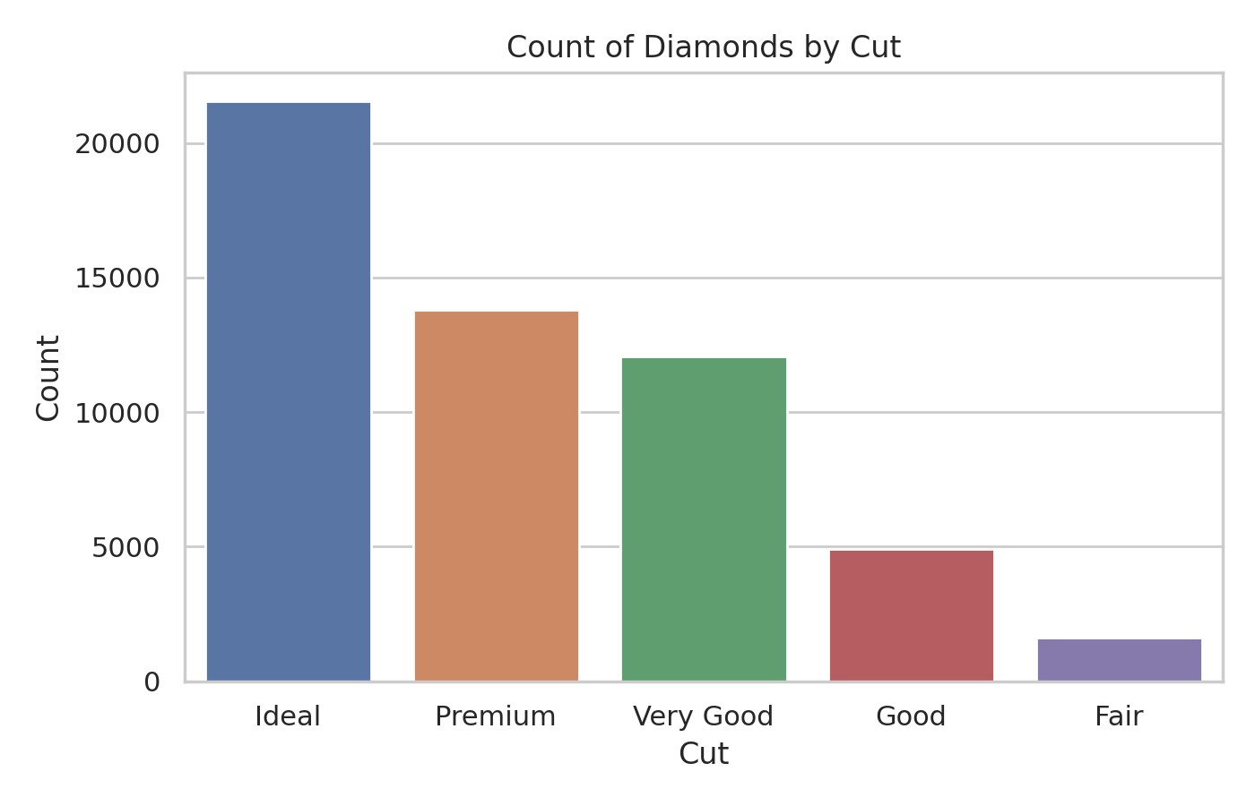
Interpretation: The countplot shows that Ideal cut diamonds are the most common category in this dataset, while Fair cut diamonds are the least common.

Boxplot
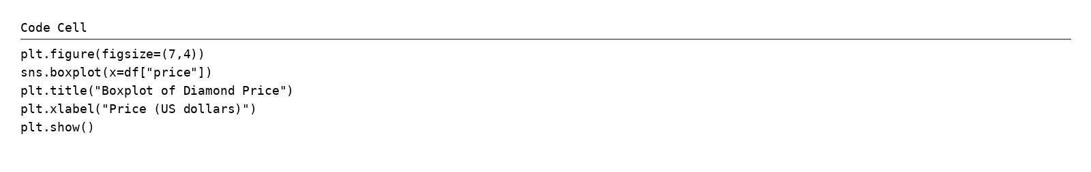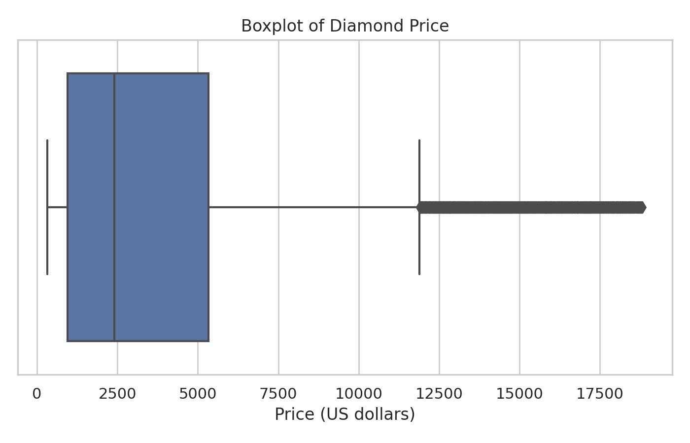
Interpretation: The boxplot shows a wide spread in price and several outliers on the higher side, meaning a small group of diamonds are much more expensive than typical diamonds.

Correlation Heatmap
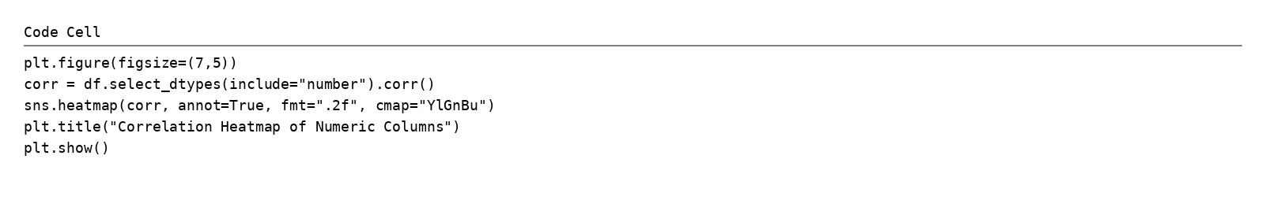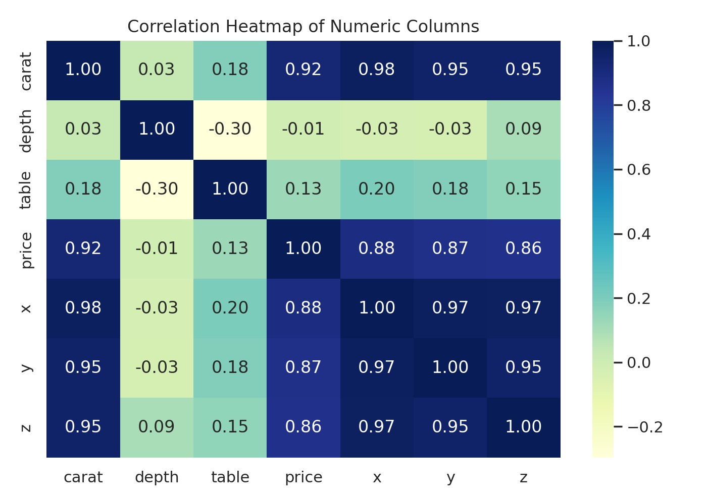
Interpretation: The heatmap shows strong positive correlation between price and carat, as well as with x, y, and z dimensions. Larger diamonds usually cost more.

Simple Prediction

Code screenshot
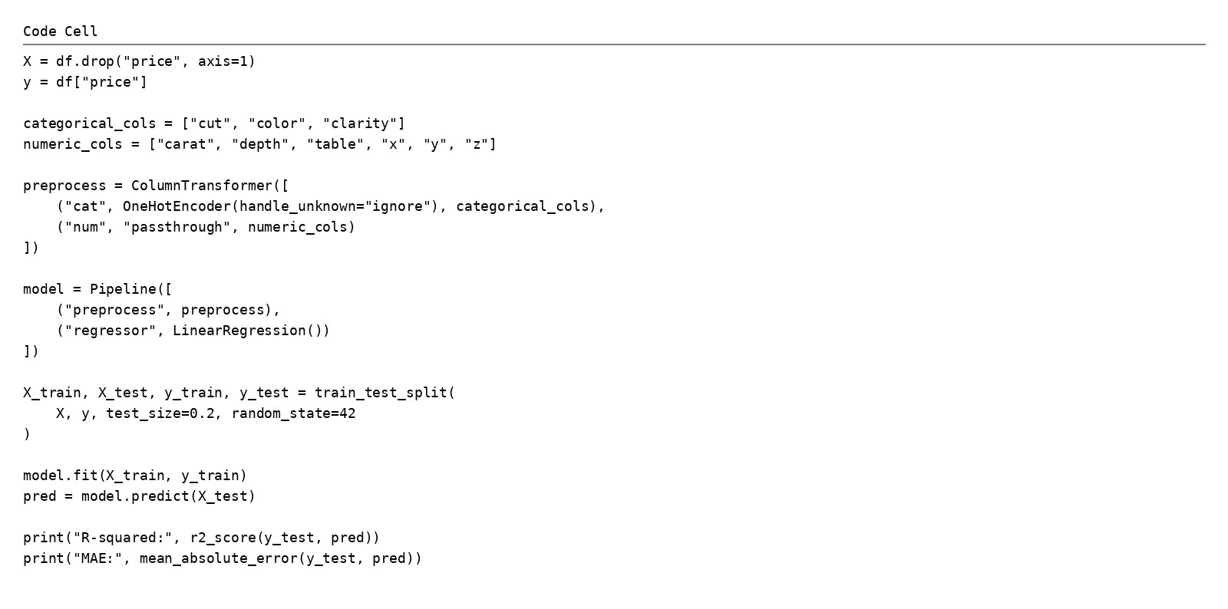

Output screenshot
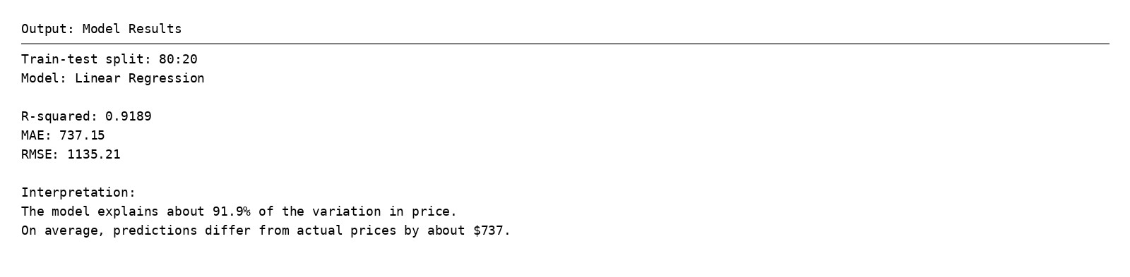
This project uses one-hot encoding for categorical columns and an 80:20 train-test split. A Linear Regression model was then trained to predict diamond price.
Result in simple English: the model explains about 91.9% of the variation in price, which means it performs well for a simple baseline model. On average, the prediction error is about $737, so the model is useful for estimation but not perfectly exact.

Insights and Recommendations
Finding 1: The histogram shows that most diamonds have lower prices and only a smaller number are very expensive.
Finding 2: The boxplot shows several high-price outliers, which means the dataset contains premium diamonds far above the usual price range.
Finding 3: The heatmap shows that carat has a strong positive relationship with price, so heavier diamonds are usually costlier.
Finding 4: The countplot shows that Ideal cut diamonds appear most often, which may affect how common certain quality categories are in the market.
Recommendation 1: A jewelry business should separate low-price and high-price diamonds while planning inventory because the prices are not evenly distributed.
Recommendation 2: Buyers should first compare carat and then check cut, color, and clarity, because size has a strong effect on price and quality features further refine the value.

Submission Checklist
This package includes the following files for your submission and GitHub repository:
File | Status
Diamond_Price_Analysis_Project.ipynb | Created
diamonds.csv | Included
README.md | Created
Perfect_Final_Diamond_Project.pdf | Created
GitHub repository upload | Do this manually before final submission
Before submitting, add your roll number and upload the CSV, notebook, README, and PDF to GitHub. Then paste the GitHub link into the PDF if your teacher requires it.

